Kenwood TS-480/TS-590

**Aki Yoshida JA1NLX and Mark Anderson WB2SMK**

**1.0 GENERAL**

Both radios basically use same CAT command and have been widely used. This section will provide basic setup and useful information.

**Note**: In this section the TS-590SG is used as a example. The TS-590S and TS-480 series will work with the same settings as well.

## 2.0 SETUP

**2.1 Setup Radio Dialog Box**

This is a Setup Radio dialog box for the TS-480HX. “Use CTS/RTS Hardware handshaking” should be checked, otherwise it may not work properly.

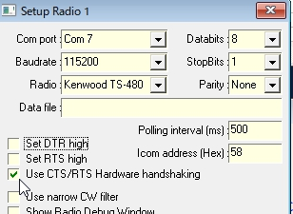

TS590_0

This is a Setup Radio dialog box for the TS-590SG

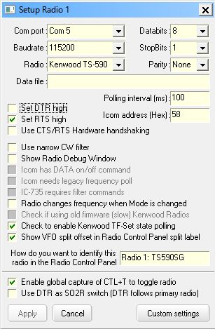

TS590_1

**Note**: There are two options to connect a PC and the TS590S for CAT control. One is to use a serial port and another is to use a USB port. If you want to use a USB port then you need to install a driver properly. See the operating manual. Baudrate is selected separately for each port in the TS-590S menu.

You need to check “Set DTR high” and/or “Set RTS high” depending on your system.

If you want to use $TF-Set$ and/or $mouseTF-Set$ macro then check “Check to enable Kenwood TF-Set state polling”.

**2.2 Setup in RCP (Radio Control Panel)**

**2.2.1 Macros configured in function buttons**

This is a sample macros configured in RCP Main.

